**DAILY ONLINE ACTIVITIES SUMMARY**

|  |  |  |  |  |  |  |  |  |
| --- | --- | --- | --- | --- | --- | --- | --- | --- |
| **Date:** | **29/05/2020** | | | | | **Name:** | **AKASH S** | |
| **Sem & Sec** | **4TH&A** | | | | | **USN:** | **4AL18CS004** | |
| **Online Test Summary** | | | | | | | | |
| **Subject** | | **OPERATEING SYSTEM** | | | | | | |
| **Max. Marks** | | **30** | | **Score** | | | **22** | |
| **Certification Course Summary** | | | | | | | | |
| **Course** | **INTRODUCTON TO PYTHON PROGRAMMING** | | | | | | | |
| **Certificate Provider** | | | **UDEMY** | | **Duration** | | | **4.5 HOURS** |
| **Coding Challenges** | | | | | | | | |
| **Problem Statement:1: Write a C Program to generate first N Armstrong Numbers**  **Problem Statement 2: Write a Java program to Find size of the largest ‘+’ formed by all ones in a binary matrix** | | | | | | | | |
| **Status: executed** | | | | | | | | |
| **Uploaded the report in Github** | | | | | **YES** | | | |
| **If yes Repository name** | | | | | [**https://github.com/akashacharya786/lockdown-c-coding**](https://github.com/akashacharya786/lockdown-c-coding)  **https://github.com/akashacharya786/lockdown-java-coding** | | | |
| **Uploaded the report in slack** | | | | | **YES** | | | |

Online Test Summary: 18CS43 online test was scheduled from 9:00am to 9:45 am. The portion for the IA was 2nd module. The question were MCQ type There were 30 question 1 mark respectively duration is 40 minutes .The score I received was 22/30.

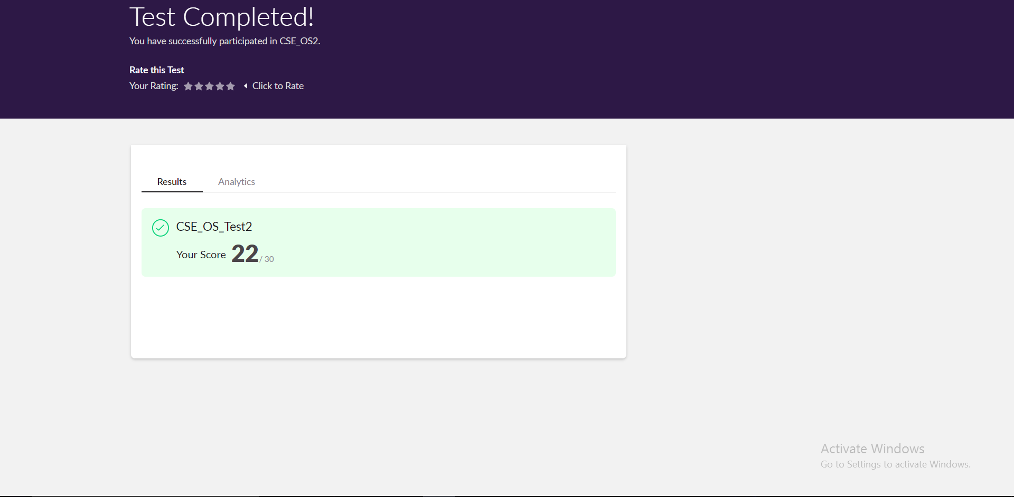

Online Certification course:

Name of the course: Introduction to python programming

Certificate provider :udemy

Today I have successfully completed Introduction to python programming course.

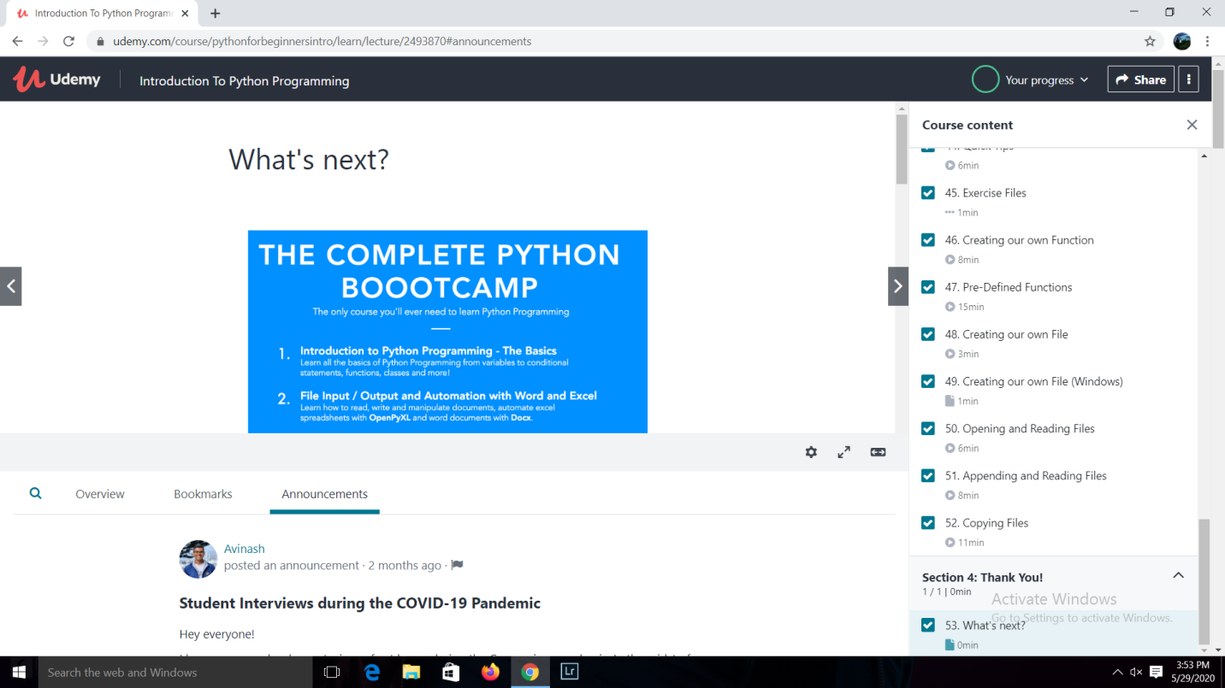

**This is the snapshot of the course.**

Online Coding summary:

1. **Write a C Program to generate first N Armstrong Numbers.**

**Snap shot**

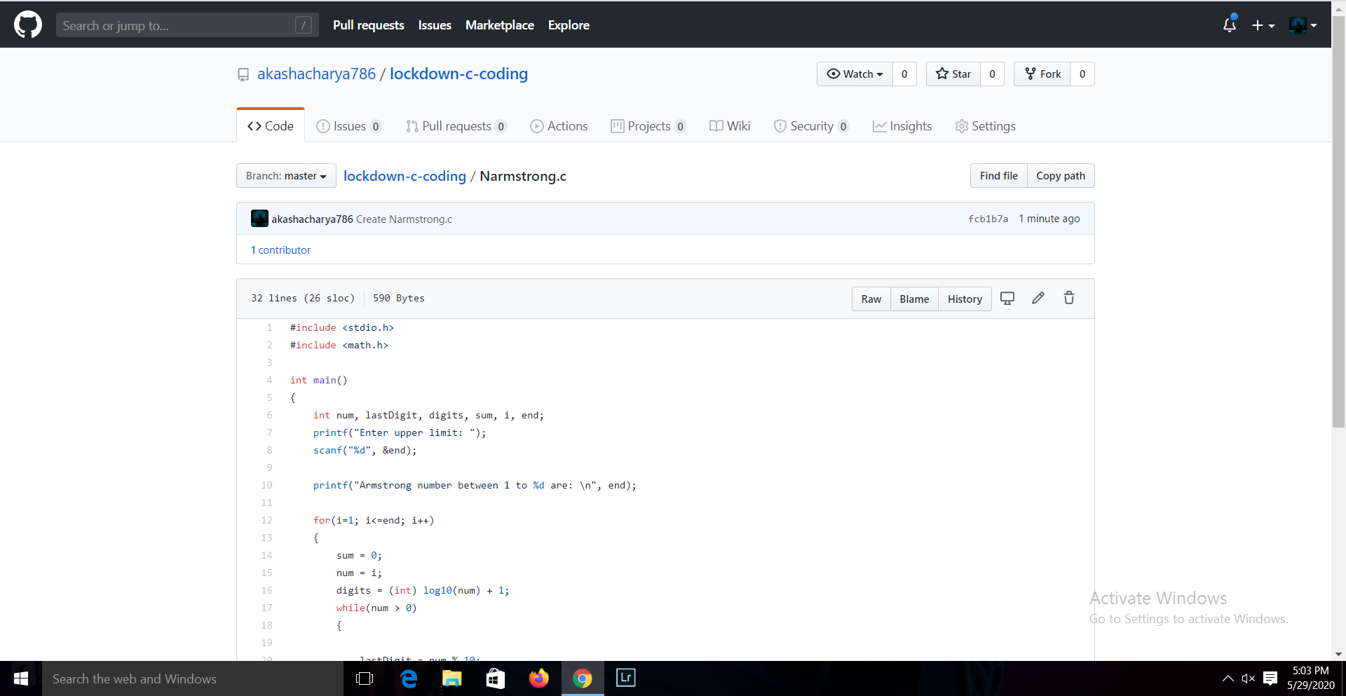

2. **Write a Java program to Find size of the largest ‘+’ formed by all ones in a binary matrix**

**Snap shot**

